MZ Info:

These bikes have a high build quality that includes - - stainless exhaust, White power shock, KTM radiators & a punchy Yamaha 660 engine.

MASTIFF and BAGHIRA
These models use the same Yamaha-sourced 660 cc five-valve single, but in all other respects are very different. Both models use a similar steel cradle frame, an alloy swinging arm, either WP or Techno-Flex rear suspension and 45 mm RWU Marzocchi forks. Both models have a single front disc with a two piston caliper and single piston rear.
The enduro-style BAGHIRA is fitted with alloy rim spoked wheels - 21" front, 18" rear - with dual-purpose tyres. The castor angle is 28 degrees, resulting in a wheelbase of 1530 mm. This is not a machine for the vertically challenged, with a seat height of 930 mm. Suspension travel is 280 mm front and rear. The popular Street-Moto version of this bike is fitted with 17" rims and road tyres.
The supermotard MASTIFF is designed to compete against bikes like the KTM Duke and is fitted with 17" spoked wheels with polished alloy rims and either Dragon Corsas or Z1 Racing road tyres. The castor angle is 26 degrees, wheelbase 1465 mm and seat height 830 mm. Suspension travel is 190 mm front and rear.

Dealers
Devon  Brown's Motorcycles  89 Mill St.,  Ottery St Mary,  E11 1AJ  ph/fax - 01404 813 853  e-mail: graham.brown@virgin.net  Sportax Racing  48 Cornwall Street  Bere Alston  Yelverton  Devon PL20 7BG  ph/fax- 01822 841063  *Rotax engine specialists* | Dorset  Three Cross Motorcycles  Woolsbridge Industrial Estate  Unit 6 Old Barn Farm Road  Three Legged Cross  Nr Wimborne  BH21 6SP  phone: 01202 824 531  fax: 01202 823 056  e-mail: sales@threecrossretail.co.uk  Fat Armadillo Motorcycle Service Centre  Unit 8, Surrey Close  Grandby Industrial Estate  Weymouth  Dorset  DT4 9TY  Tel: 01305 839 988  Fax: 01305 839 906  e-mail: fatarmadilloracing@yahoo.com | Somerset  Graham's Motorcycles  49 Priory Bridge Road  Taunton  TA1 1QB  phone: 01823 331 397  fax: 01823 327 549  e-mail: grahamsmc@mrifast.net  Ken Doyle Motorcycles  2 Throop Rd,  Templecombe,  BH8 0HR  ph/fax - 01963 370 368  Croscombe Mill Garage  Long St  Croscombe  near Wells  BA5 3QH  Phone: 01749 342 601  Fax: 01749 345 766  e-mail: dow@crosmill.freeserve.co.uk | Hampshire  BSA Company Ltd.  Speedwell House  West Quay Road  Southampton  SO15 1GY  phone: 02380 366 404  fax: 02380 366 300  e-mail: mz@bsa-regal.co.uk  A&A Motorcycles Ltd  128 Portsmouth Rd  Woolston  Southampton  SO19 9AP  Phone: 02380 437 474  Fax: 02380 685 887  e-mail: aamotorcycles@hotmail.com  Ray Dentith Motorcycles  6 London Rd,  Purbrook,  Waterlooville,  PO7 5LJ  ph/fax - 01705 230 746

PLEASE NOTE THAT THIS INFORMATION MAY NOT BE CORRECT!!!
Service Parts and Equivalents
Item | Tech note | Equivalent 1 | Equivalent 2 | Service Life
Oil Filter | As XTZ660 |  |  | 2500 miles
Air Filter
Spark Plug | DPR8EA-9 |  |  | 10,000 miles
Battery | 12v 9Ah | 12N-9A-4B-1
Chain | 520x110links |  | Hein Gericke 24001338 | Approx 6,000 miles
Front Sprocket | 15t (as XTZ 660) | JT Sprockets JTF577.15 | Hein Gericke 24001675 | Approx 1chain
Rear Sprocket | 43t (similar to XTZ 660) | JT Sprockets JTR857.43 |  | Approx 2 chains
Front Brake Pads |  | EBC FA177 |  | No idea, after 25,000 miles they still haven't worn out!
Rear Brake Pads |  | EBC FA173 | EBC FA67 (see mods page) | 4-5,000 miles
Front Disc
Rear Disc | As XJ 600 S/N, TDM 850,FZR 600 | EBC MD 2002
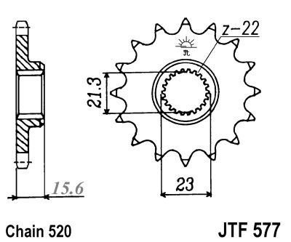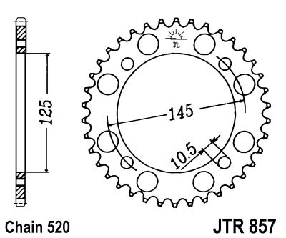
Standard rear shock settings
 | rebound | compression
White Power pre 98 | 7 | 2
White Power post 98 | 4 | 2
Technoflex | 6 | -
Spring | free length 240mm | installed length 224mm
preload | minimum 6mm | standard 16mm
minimum deflection* | no load 18.5mm | with solo rider 37mm | with passenger 63mm

JT Sprockets: JTF577-14 & JTR857-45

Bike Alert Plc.
Axion House, 1 Silver Road
London SE13 7BQ
Tel: +44 - 208 - 297 7970
Fax: +44 - 208 - 297 7992

Email Addresses:
General Enquiries: sales@bikealert.com

DID 520 VM X Ring Gold - DID 520 VM X Ring Gold:
moto-racing.co.uk
Telephone: +44 (0)1629 581552
Fax: +44 (0)1629 584394

Apex Leisure
Telephone (from the UK) - 0870 741 8878
Telephone (outside the UK) - +44 1772 635213
Fax - +44 (0)1772 634217
Email - sales@apexleisure.co.uk

